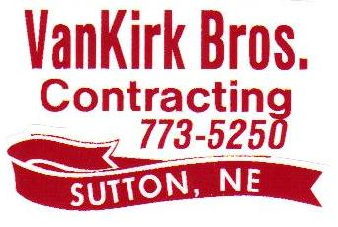
Employee Retirement

Social Security Benefits
Social Security is money that is
taken out of your check each week
*You don’t control how much*

401K
You put money into 401K Account
for your Retirement
*You control how much you put into your Retirement Account*
*Van Kirk Bros. also contributes 3% of your Annual Wage into your 401K no matter how much you choose to contribute*
Employee Stock Ownership Plan (ESOP)
This money is a Bonus to you as a Van Kirk Bros. Employee Owner!
*This is money you earn as an owner, and you do not contribute to*

