Van Kirk Bros. Contracting Construction Trades
Scholarship Application

Full Name: ____________________________________________________________________________

Address:______________________________________________________________________________

Phone: _____________________________ Date of Birth: ________________________________

Email Address: ________________________________________________________________________

Parents or Guardian: ___________________________________________________________________

Current High School & Location: __________________________________________________________

Current grade in school: _______________________ GPA: ____________________________________

Major: _______________________________________________________________________________

List the college you plan to attend and the courses you intend to take: __________________________________________________________________________________________________________________________________________________________________________

Why are you interested in Construction Related Trades? _________________________________________________________________________________________________________________________________________________________________________________________________________________________________________________________________________________________________________________________________________________________________________________________________________________________________________

What are your plans after you graduate from college? _______________________________________________________________________________________________________________________________________________________________________________________________________________________________________________________________
__________________________________________________________________________________________________________________________________________________________________________

Why do you think you are deserving of this scholarship?
_________________________________________________________________________________________________________________________________________________________________________________________________________________________________________________________________________________________________________________________________________________________________________________________________________________________________________

_____________________________________________ ______________________
Signature Date
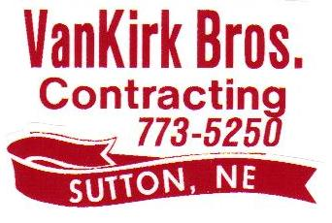

Van Kirk Sand & Gravel, Inc. was established in 1978 in Sutton, Nebraska by Jack & Carol Van Kirk. Jack and sons John, Jim and David soon began performing utility work as Van Kirk Bros. Contracting. In 2020 the business became employee owned and operated and currently employs over 100 people in Central Nebraska. Van Kirk Bros. Contracting works all over the state of Nebraska and Northern Kansas.

Van Kirk Bros. Contracting is an underground utility and heavy highway construction company. We specialize in water main, sanitary sewer, storm sewer, box culverts, sewer lagoons and highway grading. We also do general excavation work as well.

Van Kirk Bros. wants to help encourage young people to go into the construction trades. We are offering a $500 scholarship to any applicant who qualifies under the following criteria:

- Senior in High School and will graduate in Spring of 2025
- Currently resides and attends school in Clay, Hamilton, York, Fillmore, Thayer, Nuckolls, Webster, Adams & Hall Counties.
- Plan on continuing their education in a construction related field. This includes Heavy Equipment Operator, CDL Truck Driver, Diesel Technology, Construction Management

To Apply:
- Please complete the Van Kirk Bros. Contracting scholarship application
- Please attach your most current high school transcript
- Please attach one letter of recommendation. This letter can be from a teacher, school administrator or recent employer. Your recommendation letter must not be from a relative.

Please send all application documents by April 15 to:

Van Kirk Bros. Contracting
Attn: Amy Skalka
PO Box 585
Sutton NE 68979
Email: amys@vkbros.net

